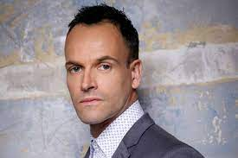

|  |  |  | **GOALS AND MOTIVATIONS** |  | **CHALLENGES AND OBSTACLES** |
| --- | --- | --- | --- | --- | --- |
| * To steal as much from people as possible * Using false info to tricky people into giving anyway money * Find ways to get past secure measures to keep scamming | * Finding ways trick people into buying fake items/sending items for free * Identifying ways to bypass security system in place to prevent scamming |
|  |  |
| **QUOTATION** | |
| I consider myself really lucky and I always have done. My approach is that if I know I'm relaxed and happy, then I will do my best work. | |
| **NAME** | |
| Jonny Lee Miller | |
| **AGE** | |  |  |
| 49 | | **FRUSTRATIONS** | **SOURCES OF INFORMATION** |
| **GENDER** | | * When a website's security system is too difficult to break * Too many requires meny to buy/sell things * Active moderators preventing scamming | **BOOKS** |
| Male | | Mansfield Park |
| **LOCATION** | | **BLOGS** |
| London | | https://fuckingyeahjonnyleemiller.tumblr.com/ |
| **OCCUPATION** | | **CONFERENCES** |
| Criminal | | https://www.pinterest.nz/pin/35325178313353412/ |
| **JOB TITLE** | | **MAGAZINES** |
| Online scammer | | https://people.com/tag/jonny-lee-miller/ |
| **HIGHEST LEVEL OF EDUCATION** | | **WEBSITES** |
| High School | | https://en.wikipedia.org/wiki/Jonny_Lee_Miller |
| **ANNUAL INCOME** | |  |

$84,000